A Minor Project Report on

Hand Gesture Based Volume Control

Submitted in the partial fulfillment for the award of the degree of

**BACHELOR OF TECHNOLOGY**

**in**

Computer Science & Engineering (AIML)

## 2021-2025

By

## Sankalp Dutta (219310268)

Priyanshu Baliyan (219310316)

## Siddhant Upadhyay (219310237)



Under the guidance of

## Mr. Surendra Solanki

**School of Computer Science and Engineering Department of Artificial Intelligence and Machine Learning Manipal University Jaipur**

**Jaipur, Rajasthan** **Jan-May 2024**

**Content**

**Table of contents**

|  |  |  |
| --- | --- | --- |
| **S.No.** | **Heading** | **Page number** |
| 1. | Introduction | 3 |
| 2. | Motivation | 3 |
| 3. | Statement of Problem | 4 |
| 4. | Methodology | 5 |
| 5. | Software/Hardware Requirements | 6 |
| 6. | Bibliography and References | 7 |

# Introduction:

Hand gesture recognition stands at the forefront of human-computer interaction, representing a dynamic fusion of technology and human expression. This research- based project delves into the realm of machine learning to pioneer robust algorithms capable of discerning and interpreting hand gestures. The goal is to foster intuitive and efficient interaction with digital devices, thereby bridging the gap between human communication and technological advancement.

Introducing a cutting-edge endeavor in human-computer interaction, our project pioneers a revolutionary method for volume control utilizing hand tracking models. By leveraging advanced algorithms capable of tracking thumb and finger movements, we aim to redefine the conventional means of adjusting audio levels. Gone are the days of fumbling with buttons or dials; instead, users can effortlessly modulate volume with intuitive hand gestures. This project not only showcases the capabilities of modern computer vision techniques but also underscores the potential for seamless integration of technology into everyday tasks.

# Motivation:

The motivation behind this project is rooted in the pursuit of inclusivity, accessibility, and innovation. At its core, the project seeks to empower individuals by providing them with a means of interaction that is both intuitive and adaptable. By harnessing the power of machine learning, we aim to unlock new possibilities for communication and engagement.

Furthermore, Traditional methods of volume control, such as physical knobs or buttons, can be cumbersome and disrupt the flow of engagement with audio devices. By harnessing the power of computer vision and gesture recognition, we aim to offer a more intuitive and seamless alternative. Additionally, this project seeks to explore the potential applications of emerging technologies in everyday settings, showcasing the transformative impact they can have on how we interact with our surroundings. Ultimately, our motivation lies in pushing the boundaries of innovation to create solutions that simplify and enrich people's lives. This approach holds particular significance for individuals with disabilities, offering an inclusive means of engagement that transcends physical limitations.

# Statement of Problem:

Despite the advancements in hand gesture recognition technology, significant challenges persist in achieving robust and accurate recognition across diverse contexts. Lighting conditions, occlusions, and variations in hand poses present formidable obstacles that must be addressed to ensure reliable performance.

Furthermore, the integration of real-time processing capabilities and scalability to accommodate a wide range of applications remain ongoing challenges in the field. This project seeks to tackle these issues head-on, leveraging state-of-the-art methodologies to develop a robust hand gesture recognition system capable of operating in real-world environments.

|  |  |
| --- | --- |
| **Pros** | **Cons** |
| **Customization:** Hand tracking systems can potentially support customizable gestures, allowing users to define their preferred gestures for volume control. | **Accuracy Issues:** Hand tracking systems may not always accurately interpret hand movements, leading to unintended or inaccurate volume adjustments. |
| **Accessibility:** Hand tracking systems can be more accessible for individuals with mobility  impairments or disabilities that make traditional controls difficult to use. | **Compatibility Issues:** Hand tracking systems may not be compatible with all devices or  operating systems, limiting their usability across different platforms. |

# Methodology:

### Data Collection:

* Identify sources for acquiring diverse datasets of hand gestures, including publicly available repositories and custom data collection efforts.
* Ensure that the dataset encompasses a broad spectrum of gestures, environmental conditions, and demographic diversity to enhance model generalization.

### Preprocessing:

- Cleanse the dataset by removing irrelevant or redundant data, standardizing image sizes, resolutions, and augmentation, and addressing any artifacts or anomalies.

### Hand Detection and Tracking:

* Hand Detection and Tracking: Utilize computer vision techniques to detect and track the user's hand in real-time. This involves selecting appropriate algorithms and frameworks (e.g., OpenCV, Media Pipe) to accurately locate and follow the hand's movements.

### Gesture Recognition:

* Train machine learning models, such as convolutional neural networks (CNNs) or recurrent neural networks (RNNs), to recognize specific hand gestures associated with volume control commands. This involves feeding the preprocessed data into the model and iteratively optimizing its performance.

### Testing and Evaluation:

* + Conduct rigorous testing to assess the accuracy, responsiveness, and reliability of the gesture-controlled volume system. This includes both simulated testing and real-world usage scenarios to identify and address any issues or limitations.
  + Thorough testing on diverse datasets to assess model generalization and robustness across different scenarios and conditions.

### Deployment and Integration:

* Integrate the trained model into user-facing applications and platforms, ensuring seamless interaction and compatibility with existing systems.
* Solicit feedback from users and stakeholders to identify areas for improvement and iterate on the model to enhance user experience and performance

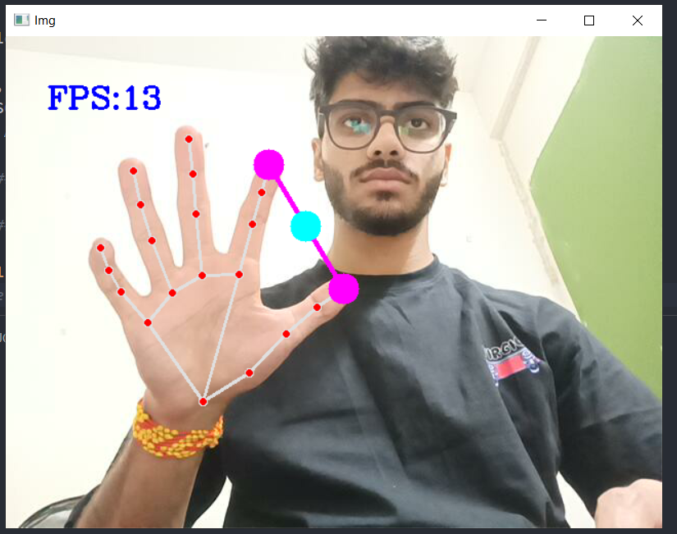

# Software/Hardware Requirements:

### Software:

* Python (programming language)
* OpenCV (computer vision library)
* Scikit-learn (machine learning library)

### Hardware:

* GPU (Graphics Processing Unit) for accelerated training (optional but recommended)
* Webcam or video input device for real-time gesture recognition

# Gantt Chart:

The Gantt chart illustrates the projected timeline for each phase of the project, outlining specific tasks and their corresponding start and end dates.

|  |  |  |
| --- | --- | --- |
| **Task** | **Start Date** | **End Date** |
| **Data Collection** | 12/02/2024 | 18/02/2024 |
| **Preprocessing** | 19/02/2024 | 25/02/2024 |
| **Hand Detection and Tracking** | 26/02/2025 | 04/03/2024 |
| **Gesture Recognition** | 05/03/2024 | 25/03/2024 |
| **Evaluation and Testing** | 26/03/2024 | 15/04/2025 |
| **Deployment and Integration** | 16/04.2024 | 06/05/2024 |

# Bibliography/References:

1. Li, C. T., & Nixon, M. S. (2004). Hand Gesture Recognition Using Shape Context Matching. Proceedings of the IEEE International Conference on Pattern Recognition.
2. Pu, J., & Black, M. J. (2020). Mocap-guided Data Augmentation for 3D Hand Pose Estimation. Proceedings of the European Conference on Computer Vision (ECCV).
3. Kolsch, H., Turk, A., & Burkhardt, H. (2005). Hand Gesture Recognition Based on Local Features: A Combination of Finger Posing and Movements. Proceedings of the IEEE Workshop on Automatic Identification Advanced Technologies (AutoID).
4. https://[www.computervision.zone/courses/gesture-volume-control](http://www.computervision.zone/courses/gesture-volume-control)